**Cold Wallet- Trezor**



Trezor is a hardware wallet used for storing bitcoins and other crypto currencies without having to trust a third party. Essentially a USB dongle, it is designed to sign bitcoin transactions with private keys generated offline within the device. It can be used to sign transactions on 'unsafe' computers and is impervious to keyloggers and other digital threats. At this moment Trezor devices support Bitcoin, Bitcoin Cash, Bitcoin Gold, Dash, Ethereum, Ethereum Classic, Litecoin, NEM, Zcash, Expanse, UBIQ, DigiByte, Monacoin and also hundreds of ERC20 tokens.Because the use of Trezor is very easy and intuitive we believe it will help Bitcoin adoption among people not familiar with the security issues.

**Installation Steps**

We recommend AWS Server or Digital ocean server for its speed, reliability and security.

**Minimum server requirements -**

**AWS:**

Free Tier - T2.Micro Plan with 8GB SSD

**Digital Ocean:**

5$ per month Plan - 1GB Ram with 25GB SSD

1. Install Apache

Our next step is to install Apache. Type the following commands in the terminal:

sudo apt-get update

sudo apt-get install apache2

You will be prompted with a (Y/n). Type y and press Enter.

You can do a spot check right away to verify that everything went as planned by visiting your server's public IP address in your web browser.

http://your_server_IP_address

You will see the default Ubuntu 16.04 Apache web page, which is there for informational and testing purposes. It should look something like this:

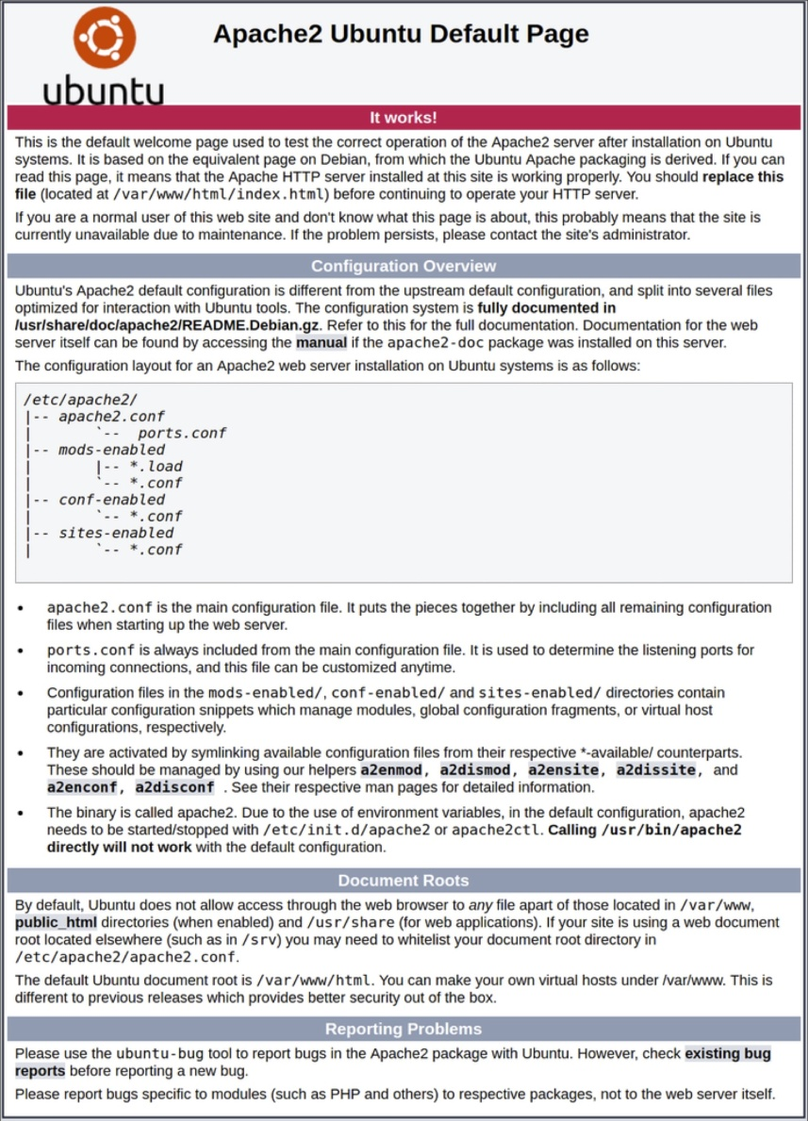

You have now installed Apache web server successfully.

2. Uploading source code to server

This section shows us how to upload the source code for the exchange to the server we've setup. We will be using FileZilla to upload the code with FTP as it is the easiest way for managing file transfers.

Download [FileZilla](https://filezilla-project.org/)and install it on your system.

Open FileZilla and go to FileZilla>Settings.

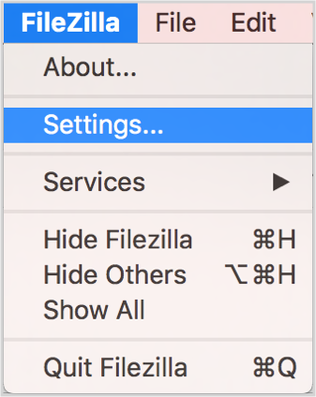

Go to SFTP tab.

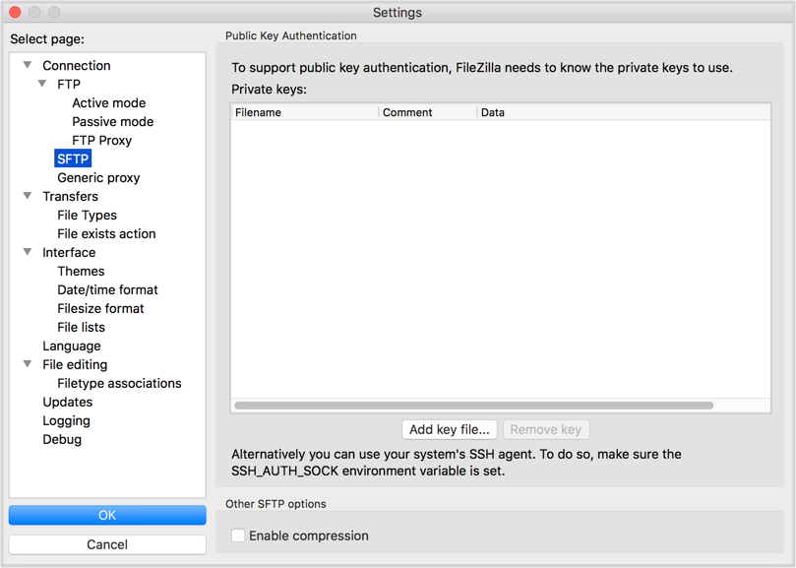

Press Add key file and select your SSH private key.

You will be prompted to enter your SSH key password. Once the key is added, press OK.

Now, enter sftp://ip_address of the droplet you want to connect in the Host field and give Username as root. Press Quickconnect to establish connection.



The left panel is your local directory and the right panel is the directory in your server. Now drag the **coldwallet.zip** you have downloaded and drop it to **/var/www/html/ folder**.

Delete the old index.html dummy file which is already there in the server in /var/www/html/

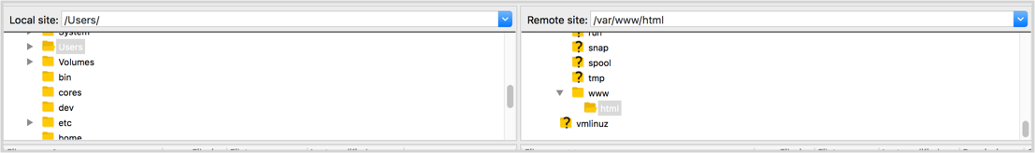

**You have now successfully uploaded the code to the server.**

3. InstallUnzip

We need to unzip the zip file we uploaded to the server in the previous step. To do so, we need to install Unzip in our server.

Enter the following commands in your Terminal and hit Enter:

sudoapt-getinstallunzip

If unzip is successful it should look like this:

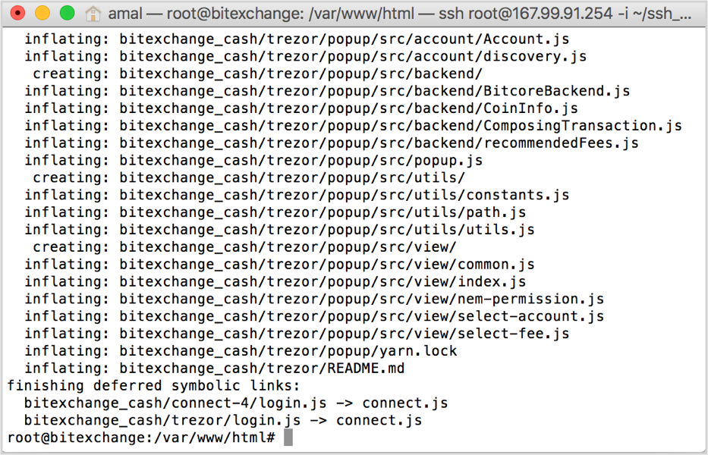

4. Unzip the source code

Navigate to the html folder:

cd /var/www/html

And type the unzip command in your Terminal and press Enter.

Unzip coldwallet.zip

**Make sure you have pointed the IP to your domain name as A record for both** [**www.yourdomainname.com**](http://www.yourdomainname.com) **and yourdomainname.com**

**Now Goto** [**www.yourdomainname.com**](http://www.yourdomainname.com) **to check the first Sign In page.**

3. Change Copyrights from footer

You will have to change in two files - index.html (Line number 159) and trezor.html (Line number 733)

**How it Works**

1) Make sure your Trezor wallet is connected to your PC before proceeding below.

2) With your Trezor cold wallet, you can Get your Crypto currency Address.

3) You can confirm and Send cryptocurrencies to other wallet addresses.

4) Get you Trezor wallet account information for all the coins.

5) You can Sign and also verify messages.

6) You have an option to Export You public key.